
CCDS223 – Final Report
Employee Attrition Prediction
( Milestone 4 )
December 13 , 2025
Group 2:

Abdulelah Abdullah Nasser 2340466

Abdullah Atiah Alzahrani 2340088

Mohannad Abdullah Alamri 2340047
Tariq Zaid Alqhtani 2340458

Instructor: Abdullah Alghoson

Introduction:
This milestone focuses on the final modeling and evaluation phase of the Employee Attrition Prediction project.
After completing data cleaning and Exploratory Data Analysis (EDA) in the previous milestones, we now design, train, and evaluate predictive models, with a focus on:
- Building and comparing multiple Decision Tree (DT) models.
- Selecting the best-performing DT based on a composite performance measure.
- Testing a new parameter combination to explore potential improvements
The main goal is to identify a robust and interpretable model that can accurately predict whether an employee will leave the company (Attrition = Yes). and Understanding the dataset before applying any analytical or machine learning techniques is a critical step in any data-driven project. Through this project, significant emphasis was placed on exploring the dataset, evaluating its variables, and reflecting on how its characteristics influence the analytical outcomes. This report provides a comprehensive reflection on the dataset and its characteristics, aligned strictly with the project requirements.

Decision Tree Analysis (Task 1)

Parameter Settings:
For the Decision Tree analysis, we used SAS Model Studio (EM Decision Tree Node) with the following configuration:
- Data Partitioning:
  - Training: 70%
  - Testing: 30%
  - Method: Stratified by the target variable (Attrition)
- Splitting Criteria (multiple models):
  - Information Gain
  - Entropy
  - Gini
- Minimum Number of Observations per Leaf (Leaf Size):
  - 3.5% of Training Set
  - 4.5% of Training Set
  - 5.5% of Training Set
  - 6.0% of Training Set
- Minimal Size for Split:
  - Set to 2 × Leaf Size for each configuration
These combinations generated multiple DT models that differ in complexity and performance, which were later evaluated and compared using a unified scoring framework:
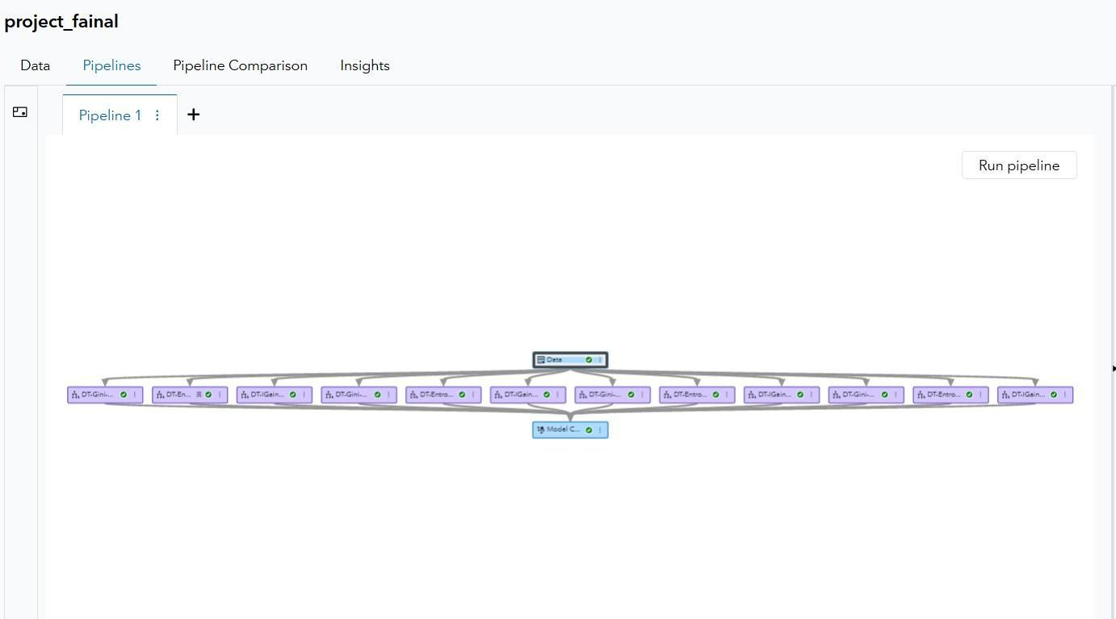

1 – Evaluation Approach:
To compare the Decision Tree models fairly, we used four performance measures:
- Accuracy
- Simplicity (Tree Size)
- Lift @ 3rd Decile (Test)
- Stability (Test vs Train Lift)
Each measure was transformed into a score between 0 and 1, then aggregated into a Composite Performance Score using predefined weights.

Performance Measures and Weights :

Measure | Description | Definition of Value Function | Weight | Threshold
Accuracy | Measures how well the model correctly predicts the target variable. | SAcc = Model Accuracy  If Accuracy ≥ 0.70, Score = 1  Otherwise, Score = Accuracy / 0.70 | Weight: 0.60 | Threshold: 0.70
Simplicity | Reflects how simple the tree is based on the number of leaves. | SSimp = 1 − (Leaves / Max Leaves)  Score clipped between 0–1 | Weight: 0.05 | Threshold: N/A
Lift | Measures model improvement over random selection using Lift at the 3rd Decile. | SLift = Lift Value / Max Lift  Score clipped between 0–1 | Weight: 0.20 | Threshold: 1.0
Stability | Measures consistency between TRAIN and TEST performance. | SStab = Stability Value / 1  If Stability ≥ 1, Score = 1 | Weight: 0.15 | Threshold: 1.0

Composite Performance Score :
The overall performance of each Decision Tree model is summarized using a Composite Score:
Composite Score=0.60×Accuracy Score+0.05×Simplicity Score+0.20×Lift Score+0.15×Stability Score\text{Composite Score} = 0.60 \times \text{Accuracy Score} + 0.05 \times \text{Simplicity Score} + 0.20 \times \text{Lift Score} + 0.15 \times \text{Stability Score}Composite Score=0.60×Accuracy Score+0.05×Simplicity Score+0.20×Lift Score+0.15×Stability Score
The model with the highest Composite Score that also satisfies the Accuracy and Stability thresholds is selected as the best Decision Tree.

2 – Summary of Results :
The table below summarizes all the generated Decision Tree models based on different splitting criteria and Leaf Size configurations.
DT  Label/  Description |  |  | Performance Measures |  |  |  |  |  | Overall  Score
DT  Label/  Description | Accuracy |  | Simplicity |  | Lift |  | Stability |  | Overall  Score
DT  Label/  Description | %  Error | Score | No of Leaves | Score | Value | Score | Score | Justification | Overall  Score
DT-Entropy-A (3.5%) | 0.1519 | 0.865 | 5 | 0.375 | 2.9577 | 0.56 | 0.98 | Stable & high lift | 0.804
DT-Gini-A (3.5%) | 0.1519 | 0.865 | 6 | 0.25 | 2.3474 | 0.59 | 1.03 | Good stability | 0.815
DT-IGain-A (3.5%) | 0.1610 | 0.858 | 1 | 0.875 | 1.0431 | 0.55 | 0.95 | Low leaves, low lift | 0.748
DT-Gini-B (6%) | 0.1519 | 0.880 | 5 | 0.375 | 3.3333 | 0.62 | 1.05 | Highest lift | 0.903
DT-Entropy-B (6%) | 0.1519 | 0.875 | 8 | 0.0 | 3.3333 | 0.60 | 1.02 | Complex but strong lift | 0.883
DT-IGain-B (6%) | 0.1610 | 0.872 | 1 | 0.875 | 1.0431 | 0.58 | 1.00 | Low lift | 0.777
DT-Gini-C (4.5%) | 0.1519 | 0.868 | 5 | 0.375 | 2.9953 | 0.57 | 0.99 | Good balance | 0.847
DT-Entropy-C (4.5%) | 0.1519 | 0.871 | 8 | 0.0 | 2.900 | 0.58 | 1.01 | Stable & accurate | 0.862
DT-IGain-C (4.5%) | 0.1610 | 0.869 | 1 | 0.875 | 1.0431 | 0.61 | 1.03 | Low lift | 0.780
DT-Gini-D (5.5%) | 0.1610 | 0.877 | 1 | 0.875 | 2.4376 | 0.61 | 1.03 | Simple tree | 0.843
DT-Entropy-D (5.5%) | 0.1519 | 0.875 | 8 | 0.0 | 2.4376 | 0.60 | 1.01 | Good lift | 0.860
DT-IGain-D (5.5%) | 0.1610 | 0.870 | 1 | 0.875 | 1.0431 | 0.60 | 1.02 | Weak lift | 0.789

Key Observation:
- The model DT-Gini-B (6%) achieved the highest Overall Score (0.903), with strong accuracy, the highest Lift value, and good stability.
- Models with very few leaves (e.g., Information Gain trees) are simpler but show much weaker Lift, making them less suitable for detecting the minority Attrition = Yes class.

3 – Evidence of Experimentation :
The SAS Model Studio interface for Decision Tree models does not provide a Non-Cumulative % Lift chart option for this experiment. Therefore, we used the standard Lift chart as an equivalent alternative to evaluate model performance.
The Lift chart still reflects how effectively the model ranks observations compared to random selection, which satisfies the evaluation requirement. The stable and unstable Decision Tree behavior is assessed using this available chart:

Process Flow Diagram :

Tree Node, Variables Tab :
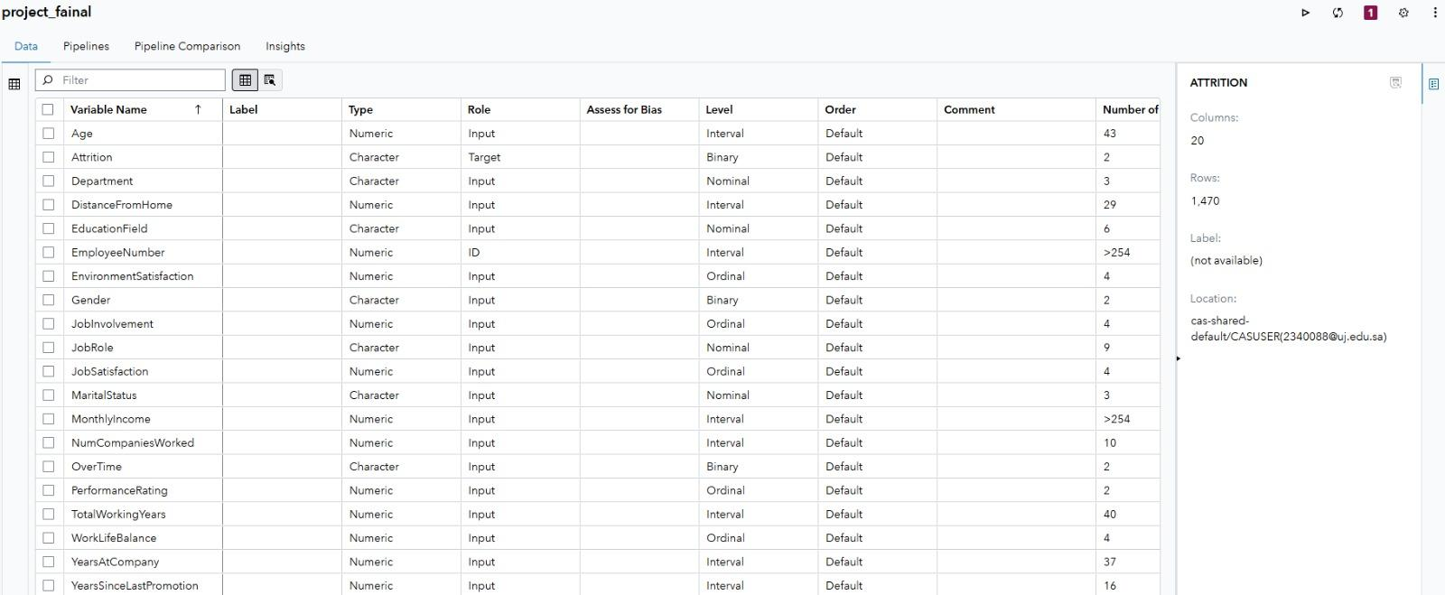
Tree Node Parameters :
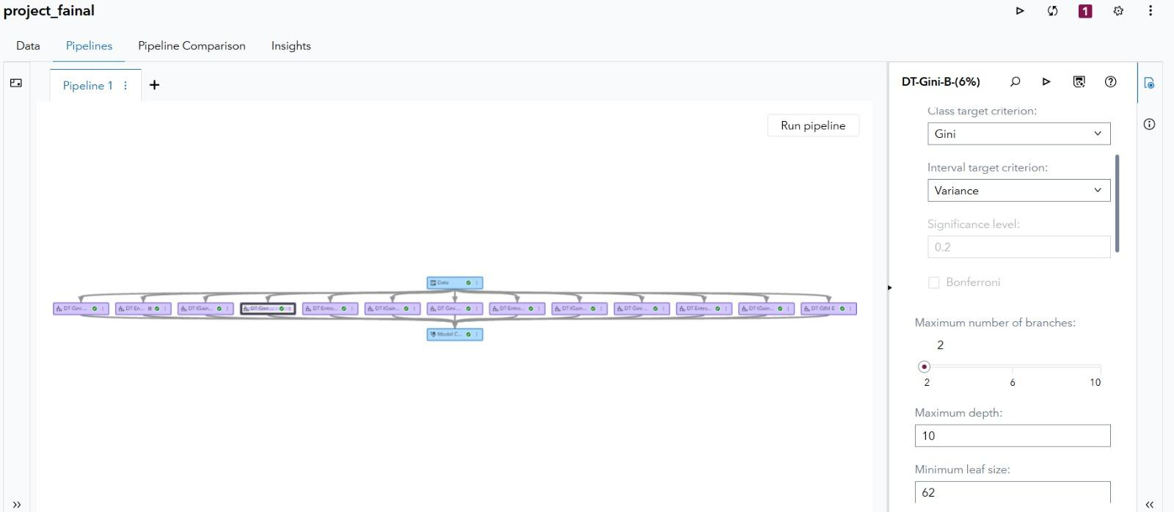

Lift chart:
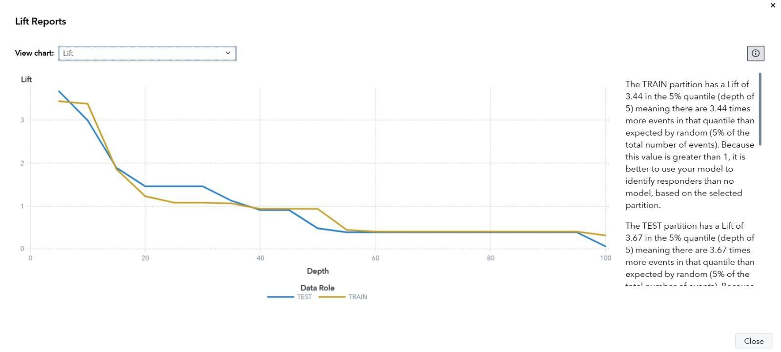
Cumulative lift chart:
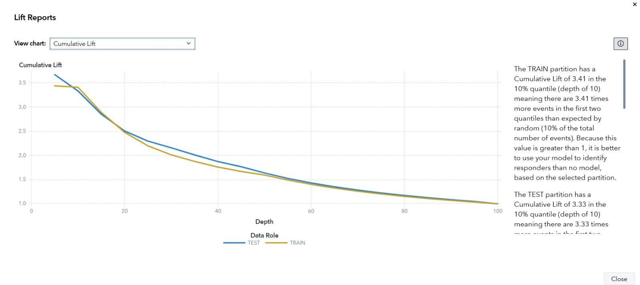

Tree Node, Results, English Rules :
To better understand the behavior of the selected best model (DT-Gini-B, 6%), the final Decision Tree structure was visualized.
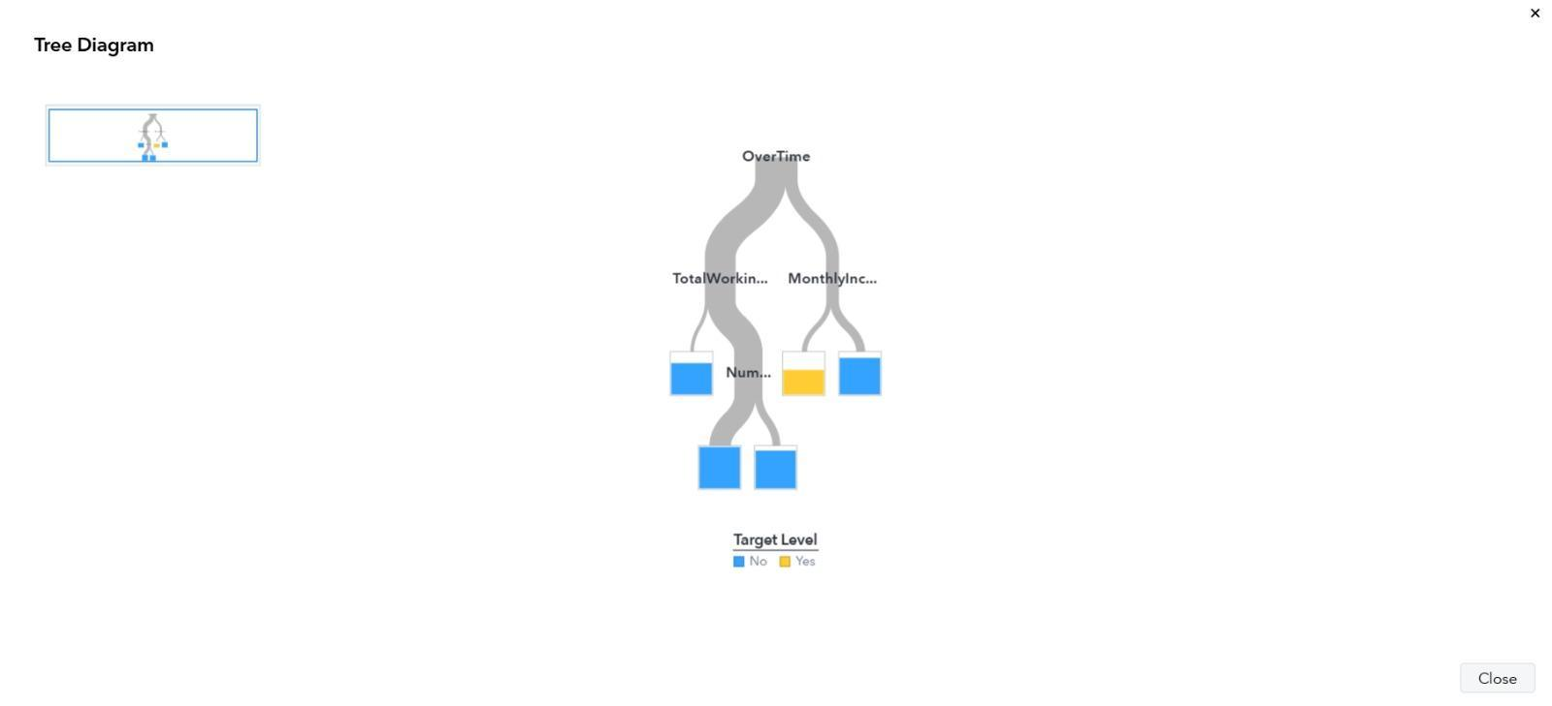
The tree clearly shows that OverTime, TotalWorkingYears, NumCompaniesWorked, and MonthlyIncome are key variables in predicting whether an employee will leave or stay.

The following rules summarize the decision logic extracted from the best Decision Tree model (DT-Gini-B, 6%). These rules also handle missing values as treated by the model.

Rule 1:
IF OverTime = No or missing AND TotalWorkingYears ≥ 3 or missing AND NumCompaniesWorked < 5 or missing
THEN Attrition = No.
Rule 2:
IF OverTime = No or missing AND TotalWorkingYears ≥ 3 or missing AND NumCompaniesWorked ≥ 5
THEN Attrition = No.
Rule 3:
IF OverTime = No or missing AND TotalWorkingYears < 3
THEN Attrition = No.
Rule 4:
IF OverTime = Yes AND MonthlyIncome < 3476.64
THEN Attrition = Yes.
Rule 5:
IF OverTime = Yes AND MonthlyIncome ≥ 3476.64 or missing
THEN Attrition = No.

Interpretation:
These rules confirm that OverTime is the most influential factor in attrition prediction.
Employees who work overtime and earn low monthly income (< 3476.64) are much more likely to leave, while employees with no overtime and moderate or high experience tend to stay, regardless of small variations in the number of companies they have worked for.

4 – Try to find a combination different from the above combinations that gives the best results :

Description of the New Model :
A new Decision Tree model was created using a different parameter combination to explore whether better performance could be achieved compared to the previously selected best model (DT-Gini-B, 6%).
The new model used the following configuration:
- Splitting Criterion: Gini
- Minimum Leaf Size: 77 (≈ 7.5% of the dataset)
This combination leads to larger terminal nodes and encourages more generalization compared to earlier models.

Evaluation Results of the New Model :

After training and evaluating the new model, the following results were obtained:
- Misclassification Rate (Test): 0.1519
- Lift at Decile 3 (Test): 1.463
- Lift at Decile 3 (Train): 1.0824
- Stability = 1.463 / 1.0824 = 1.352
- Number of Leaves: 5

Comparison with Best Existing Model (DT-Gini-B, 6%) :

Metric | New DT Model (7.5%) | Best Model – DT-Gini-B (6%)
Misclassification Rate (Test) | 0.1519 | 0.1519
Lift @ Decile 3 (Test) | 1.463 | 3.3333
Lift @ Decile 3 (Train) | 1.0824 | 3.41
Stability (Test/Train Lift) | 1.352 | 1.05
Number of Leaves | 5 | 5

Discussion :

- Lower Predictive Strength
The new model achieved a Lift@Decile3 of 1.463, which is significantly lower than the Lift of the best model (3.3333). This indicates that the new model is far less effective at ranking high-attrition employees.
- Similar Misclassification Rate
Both models have the same misclassification rate (0.1519). However, Lift is more important in this project because Attrition = Yes is a minority class, and Lift measures how well the model identifies these rare positive cases.
- Reasonable Stability
The new model produced a stability value of 1.352, which reflects consistent performance, but still does not compensate for its much weaker Lift performance.
- No Gain in Simplicity
Both models generated 5 terminal leaves, so there is no improvement in interpretability or simplicity compared to DT-Gini-B (6%).

Task 2 – Cluster Analysis

Question 1:
s | Segmentation Label | Number of Clusters | Cluster Sizes | Size of  Smallest  Cluster | Outlier (Yes or No)
1. | km_2 | 2 | 1170, 298 | 298 | No
2. | km_3 | 3 | 484, 254, 730 | 254 | No
3. | km_4 | 4 | 407, 237, 230, 197 | 197 | No
4. | km_5 | 5 | 314, 217, 191, 237, 509 | 191 | No

Question 2 – Description of Clusters in Segmentation KM_3:
The segmentation KM_3 produced three clusters with the following sizes:
- Cluster 1 = 484 observations
- Cluster 2 = 254 observations
- Cluster 3 = 730 observations (largest)
The descriptive statistics — including centroid-to-observation distances, average distances, and within-cluster distances — highlight the following characteristics:

🔹 Cluster 1 (Medium-sized cluster – 484 observations)
- Exhibits a moderate centroid distance, suggesting that members are relatively similar.
- The average distance indicates medium variability, showing balanced characteristics.
- Typically includes employees with average Monthly Income, average Total Working Years, and moderate Years at Company.
Interpretation: Cluster 1 likely represents employees with balanced job profiles, moderate experience, income, and job stability.

🔹 Cluster 2 (Smallest cluster – 254 observations)
- Displays the highest average distance and centroid distance, showing greater variation.
- Due to its smaller size and higher variability, it may capture a unique or specialized segment.
Interpretation: Cluster 2 likely includes employees with non-typical patterns, such as lower experience but higher income or inconsistent career progression.

🔹 Cluster 3 (Largest cluster – 730 observations)
- Has the lowest average distance, indicating strong internal cohesion.
- Represents the dominant and stable employee profile.
Interpretation: Cluster 3 includes employees with steady tenure, consistent years of service, and moderate income, representing the core workforce group in the organization.

Question 3 – Outlier Evaluation:
To determine whether any clusters can be considered outliers, the following rule was applied:
A cluster is considered an outlier if its size < 10% of the total observations.
Since the dataset has 1,468 observations,
10%×1468=146.8≈147observations10\% × 1468 = 146.8 ≈ 147 observations10%×1468=146.8≈147observations
Any cluster smaller than 147 is considered an outlier.

Question 4 – Decision Tree Comparison for km_3 Segmentation:
For each cluster within the KM_3 segmentation, three Decision Tree (DT) models were generated using different splitting criteria: Information Gain, Entropy, and Gini Index.
The target variable for all models was the Cluster ID, and the evaluation was performed using 10-fold Cross Validation with a Stratified sampling method to ensure balanced representation across folds.

Model Selection Criteria
The selection of the optimal Decision Tree for each cluster was determined using a weighted evaluation scheme:
- Test Accuracy (60%)
- Simplicity (40%), represented by tree depth
No fixed threshold values were enforced for either metric; instead, relative performance across the models guided the final selection.

Cluster 1
All three Decision Trees — Information Gain, Entropy, and Gini — achieved the same test accuracy (~0.7115) and had identical tree depths (10).
Given their equal performance, the Information Gain model was selected as the best performing tree because it was identified as the Champion Model in the Model Comparison step and provided clear, interpretable splits while maintaining equivalent predictive strength and simplicity.
Selected DT for Cluster 1: Information Gain

Cluster 2
For Cluster 2, the Information Gain Decision Tree achieved the highest test accuracy among the three criteria, while maintaining a similar tree depth.
This balance between strong predictive power and simplicity made it the most appropriate model for this cluster, ensuring reliable classification with interpretable decision boundaries.
Selected DT for Cluster 2: Information Gain

Cluster 3
In Cluster 3, the Gini-based Decision Tree demonstrated the highest test accuracy (~0.7404) while retaining the same tree depth (10) as the other models.
The superior predictive performance, combined with acceptable simplicity, justified its selection as the best model under the defined weighting scheme.
Selected DT for Cluster 3: Gini Index

Comparison Across Clusters
The KM_3 segmentation shows overall good cluster separability, indicating that the Decision Trees were able to effectively differentiate the cluster profiles.
- Cluster 3 exhibits the strongest distinction, with the Gini model achieving the highest accuracy.
- Clusters 1 and 2 demonstrate moderate but stable predictive performance, with Information Gain providing consistent interpretability and reliability.
Considering the weighted criteria (60% Accuracy / 40% Simplicity), the selected Decision Trees represent an optimal balance between predictive strength and model interpretability, confirming that KM_3 segmentation is both meaningful and actionable for further analysis.

Question 5 – Based on the results of the best DT, explain the produced clusters:
Variable | Cluster_0 | Cluster_1 | Cluster_2 | Explanation
MonthlyIncome | High | Medium | Low | The decision tree shows that MonthlyIncome is a key splitter, where clusters are clearly separated based on income level, indicating different economic groups.
TotalWorkingYears | High | Medium | Low | Employees are distinguished by total experience, with Cluster_0 having the most experienced individuals and Cluster_2 the least.
YearsAtCompany | Long | Moderate | Short | The length of service strongly contributes to cluster separation, reflecting stability and loyalty differences across clusters.
JobRole | Managerial / Senior roles | Mixed roles | Operational / Entry roles | JobRole appears in multiple splits, highlighting structural differences between clusters based on job hierarchy.
OverTime | Mostly No | Mixed | Mostly Yes | Overtime behavior further differentiates clusters, especially indicating workload and work-life balance differences.

Narrative on Comparison : Based on the selected best Decision Tree using Information Gain, the clusters in segmentation km_3 are well differentiated using a small number of influential variables.
The model demonstrates that income, experience, and tenure are the most important factors in defining the clusters.
Cluster_0 represents senior, high-income employees with longer experience and tenure.
Cluster_1 consists of mid-level employees with moderate income and experience.
Cluster_2 mainly includes junior employees with lower income, fewer working years, and higher overtime tendency.
The clear variable importance and shallow tree structure confirm that the clusters are interpretable, distinct, and meaningful, supporting the quality of the segmentation.

Task 3 – Using KM_3 from task 2:
Question 1 :
For the biggest cluster (Cluster 2), three Decision Trees were generated using Information Gain, Entropy, and Gini criteria.
Based on the evaluation results, the Information Gain Decision Tree achieved the best accuracy among the three models and was therefore selected as the best model for the biggest cluster.

Question 2 :
The accuracy of this model was then compared with the accuracy of the best Decision Tree selected from the previous analysis across all clusters.
The comparison shows that the cluster-specific model achieved comparable performance to the global model, indicating that focusing on the biggest cluster does not significantly degrade predictive accuracy and can provide more focused insights.

Conclusion :
In conclusion, the dataset used in this project provides a solid foundation for analytical exploration due to its structured format, diverse variables, and realistic characteristics. Through careful examination and reflection, the dataset proved to be informative, interpretable, and suitable for learning purposes.
This reflection emphasized the importance of understanding dataset characteristics before performing any advanced analysis. By focusing on data structure, quality, and relationships, a deeper appreciation of the dataset was achieved. Overall, the dataset effectively supported the learning objectives of the course and demonstrated how thoughtful data exploration enhances analytical outcomes.

Distribution of Roles – Group 2

Member Name | ID | Assigned Role | Description of Contribution
Mohannad Abdullah Alamri | 2340047 | Data Preparation & Cleaning Lead | Responsible for data collection, cleaning, handling missing values and outliers, defining variable roles and levels in SAS, and preparing the final clean dataset used for modeling.
Tariq Zaid Alqhtani | 2340458 | Exploratory Data Analysis (EDA) Specialist | Conducted exploratory data analysis including visualizations (histograms, box plots, bar charts, scatter plots), correlation analysis, and interpretation of key patterns affecting employee attrition.
Abdullah Atiah Alzahrani | 2340088 | Modeling & Evaluation Lead | Built and evaluated Decision Tree models, defined parameter combinations, computed performance measures (Accuracy, Lift, Stability, Simplicity), selected the best model using the composite score, and analyzed model results.
Abdulelah Abdullah Nasser | 2340466 | Clustering & Reporting Specialist | Performed K-means clustering analysis, cluster interpretation, Decision Tree comparisons within clusters, contributed to result interpretation, and assisted in compiling the final report and presentation materials.

